IAM/2006/CRP.1
4 January 2006
___________________________________________________________________________________
Inter-Agency Meeting on

Outer Space Activities
Twenty-sixth session
Paris, 18 – 20 January 2006

INFORMATION FOR PARTICIPANTS

A. PLACE OF THE MEETING

Opening date and place of the session

1. The twenty-sixth session of the Inter-Agency Meeting on Outer Space Activities will be held at the Headquarters of the United Nations Educational, Scientific and Cultural Organization (UNESCO), 7 Place de Fontenoy, 75007 Paris. The nearest subway station is Cambronne, Line 6. Please note that “Ségur” station is closed for renovation.

2. The session will begin on Wednesday, 18 January 2006, at 10:00 a.m. in Meeting Room VII (level – 1). The morning sessions will start at 10:00 a.m. and the afternoon sessions will start at 3:00 p.m.

Security: registration and conference passes

3. Security regulations at the UNESCO Headquarters require that all participants possess conference/grounds passes. To enter UNESCO buildings, the participants of the Meeting must receive conference passes at the UNESCO reception desk. Details on registration will be provided to participants at a later date.

Catering services

4. The cafeteria and the restaurant in Fontenoy building are located on the 7th floor. They are open from 11:30 a.m. to 2:30 p.m. The Delegates’ Bar is located in the basement of the Fontenoy/Conference building. It serves coffee, tea, drinks, cakes and sandwiches all day, with hot and cold meals for lunch and dinner. The Delegates’ Bar is open from 8:30 a.m. to 9:00 p.m.

Banks

5. “Société Générale” branch is located on the first floor of Fontenoy building (opposite the lifts). It is open from 9:30 a.m. to 11:30 a.m. and from 13:00 p.m. to 4:15 p.m.. The telephone number for this branch is 01 53 69 55 60 or 81640. A 24-hour cash dispenser is located on the ground floor of Fontenoy building (Espace Miró).

Telephone services

6. To call UNESCO switcboard from abroad, dial +33. 1. 45.68.10.00. To call UNESCO switchboard within France, dial 01 45 68 10 00. Note that all telephone numbers within France have 10 digits starting with 0. To call a UNESCO extension number directly, replace the last four digits by the extension number, eg +33.1. 45684126 (from abroad) or 0145684126 (within France). To call an extension number within UNESCO, dial the last five digits starting with 8, eg 84126. Dial 0 for outside line. See attached “Useful telephone numbers” sheet for additional information.

Lost and found
7. If you have lost or found something, please contact the Delegates’ reception or the Guard Service (Tel.: 81636).

Book and souvenir shops

8. UNESCO’s book and souvenir shops are located on the ground floor of the Fontenoy building (near the lifts). The book shop sells UNESCO publications, CDs, CD-ROMs and certain United Nations publications. You will also find trade-marked UNESCO gifts and numismatic and philatelic items. The UNICEF shop is also located in the ground floor of the Fontenoy building, next to the UNESCO book and souvenir shops. The shops are open Monday through Friday, from 9:00 a.m. to 6:00 p.m. (Tel.: 82222, 80370)

Newspapers

9. A newsagent is located on the ground floor of the Fontenoy building and offers daily newspapers, magazines and books.

Library

10. UNESCO’s library is located on the ground floor of the Fontenoy building (R.004). Opening hours are: Monday to Friday, 9:30 a.m. to 6:00 p.m. (Tel.: 80356/60).

Secretariat

Office for Outer Space Affairs
United Nations Office at Vienna
Wagramerstrasse 5, A-1400 Vienna, Austria
Tel: +43 1 26060 4950
Fax: +43 1 26060 5830
E-mail: oosa@unvienna.org
Web site: http://www.oosa.unvienna.org

Focal point(s) for the Meeting

Ms. Yolanda Berenguer
Space Education Programme Coordinator
Tel: +33 1 45 68 41 71
Fax: +33 1 45 68 58 22

Ms. Sophia Laryea
Division of Ecological and Earth Sciences
Direct tel: +33 1 45 68 41 26
Direct fax: +33 1 45 68 58 22

B. TRAVEL INFORMATION

Language, Currency and Credit Cards
The language spoken in France is French. The currency used is the Euro (€). Most hotels, restaurants and shops accept internationally valid credit cards.

Climate
The average temperature in January is approximately 3°C, or 37.4 °F. The average precipitation is 46 mm.

Time Zone
France follows Central European Time, which is Universal Coordinated Time + 1, during the period of the session.

Electricity
The electric voltage is 220 volts (50 cycles). A standard voltage converter and plug adapter should be sufficient for conversions. Normally, the electrical outlets in Paris require a two-prong plug with round prongs. Computer modems require a European plug adapter and phone jack adapter.

Getting from airports to the city

From Charles-de-Gaulle-Roissy airport (north of Paris):
1. By Air France (AF) shuttle bus (approx 12 Euros): AF buses have different destinations: Charles de Gaulle Etoile, Montparnasse, Invalides, Opera. The final destinations are next to subway stations that have the same names.
2. By RER (suburban) train linking to subway (metro) lines (Note: When buying a ticket, indicate use of both trains).
3. By taxi (approx Euro 50-60).

From Orly airport (south of Paris)
(a) By Orlybus to subway (metro) stop “Denfert Rochereau”.
(b) By taxi (approx. Euro 30 – 40).

List of hotels in Pa is available upon request.
Eiffel Tower (at the tip of the frame)
Metro: Ecole Militaire
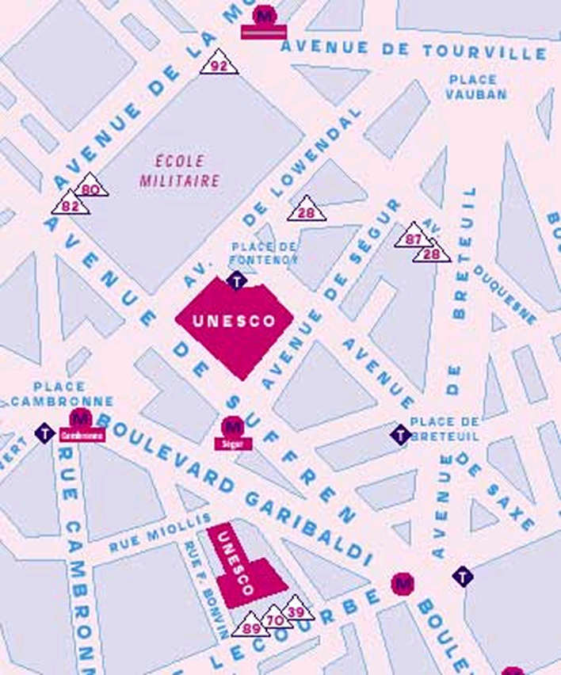
Metro: Cambronne
Metro: Segur (closed)
UNESCO, 7 Place de Fontenoy, 75007 Paris
UNESCO, 1 rue Miollis, 75015 Paris
T = Taxi stand
= Bus stand

